**ASSIGNMENT**

**Date :** 12/07/2024

Radhidevi K

73772126140

B.Tech AIDS – 4th year

**Git Lab : --------**

**1. Create a local git repo with the name "MyRepo".**

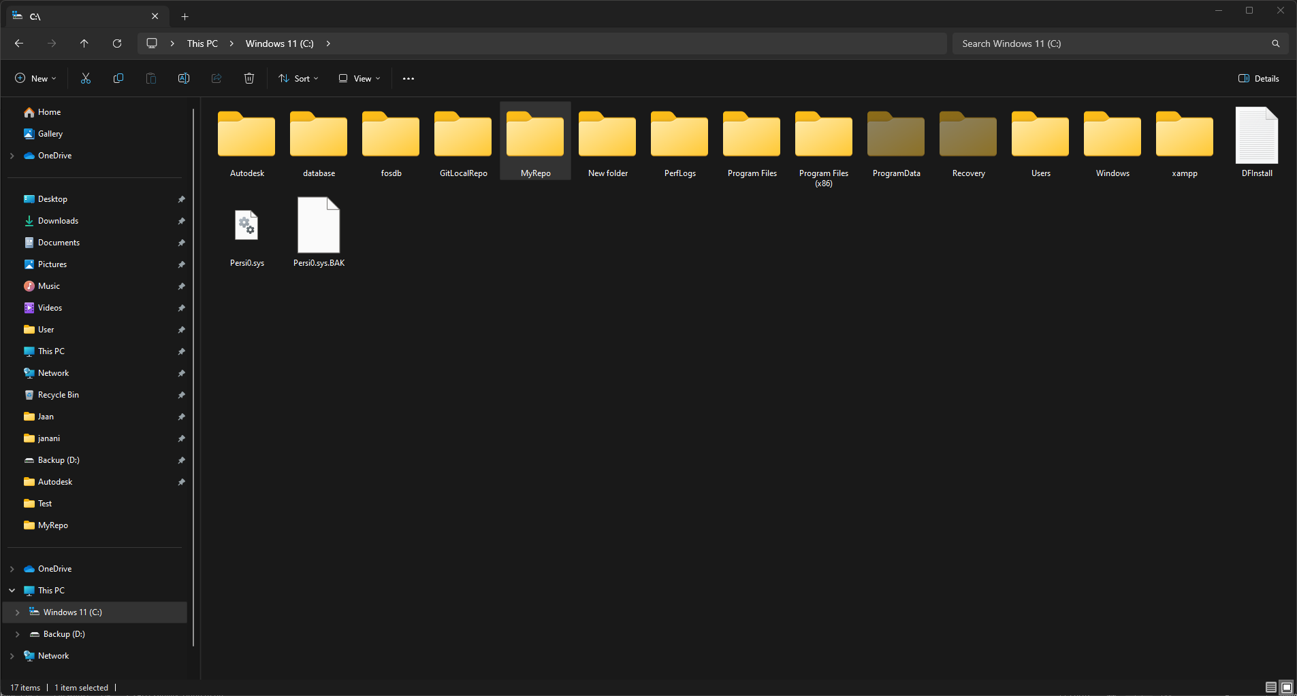

**2. create one .txt file, five .c files and five .java files in the working area.**

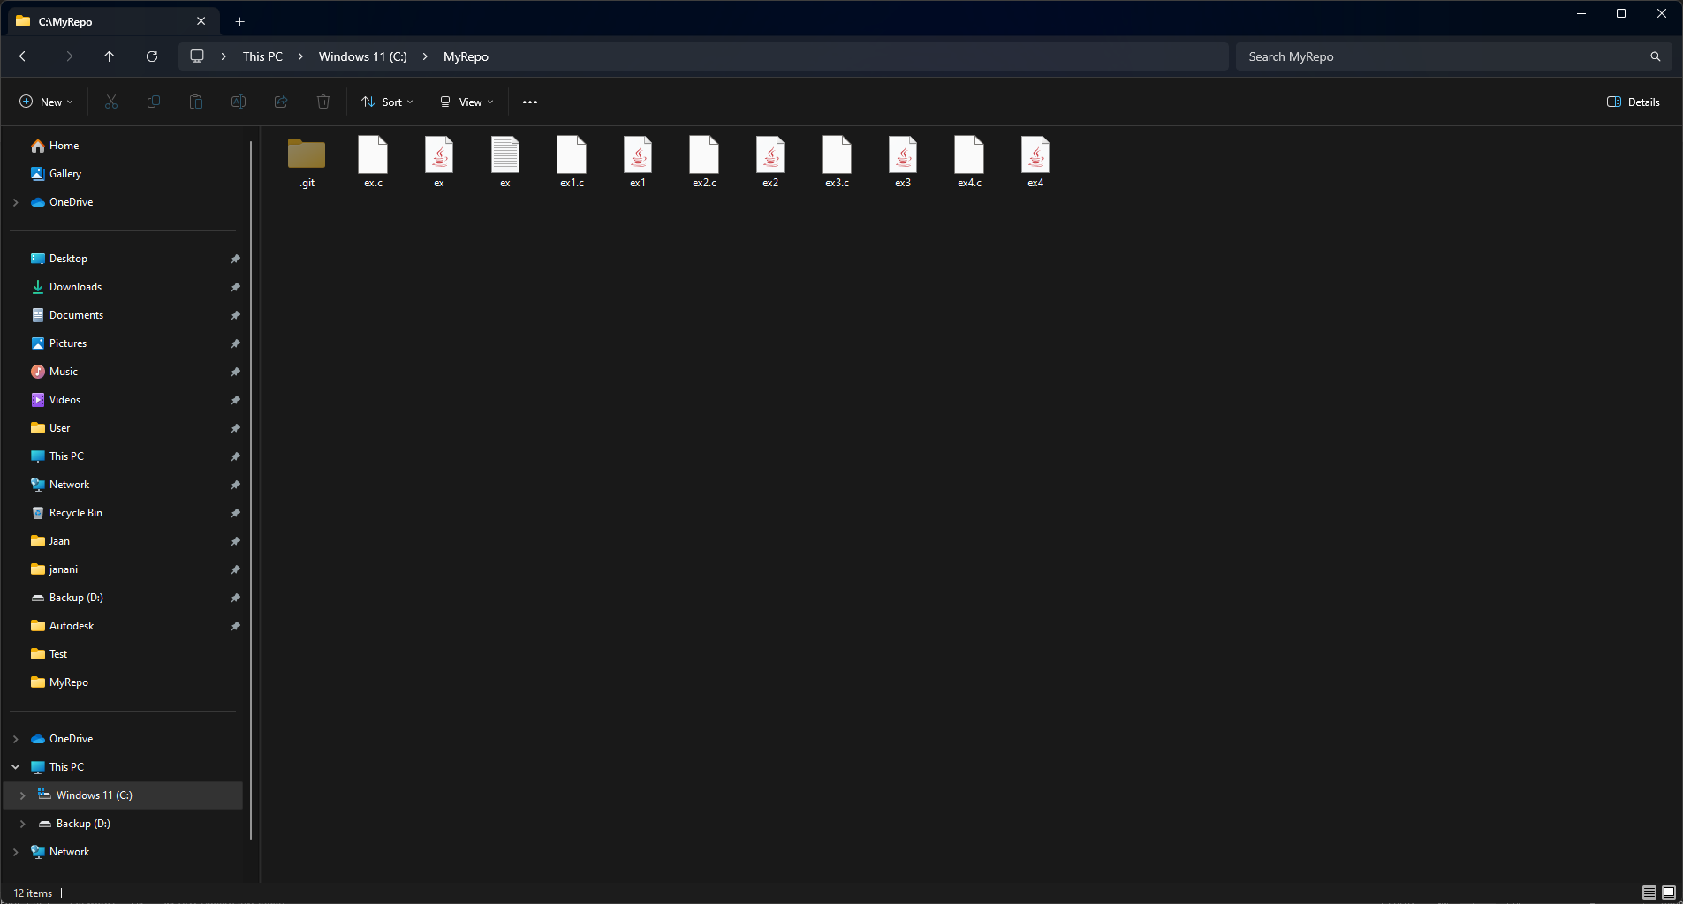

**3. Verify the git status**

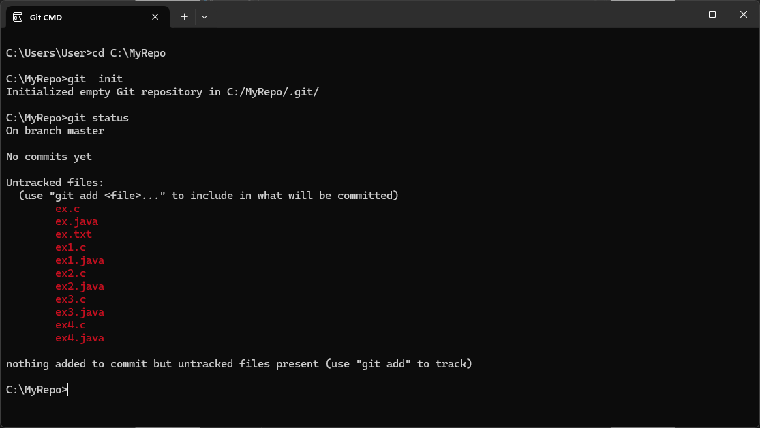

**4. Add only the .txt into the staging area**

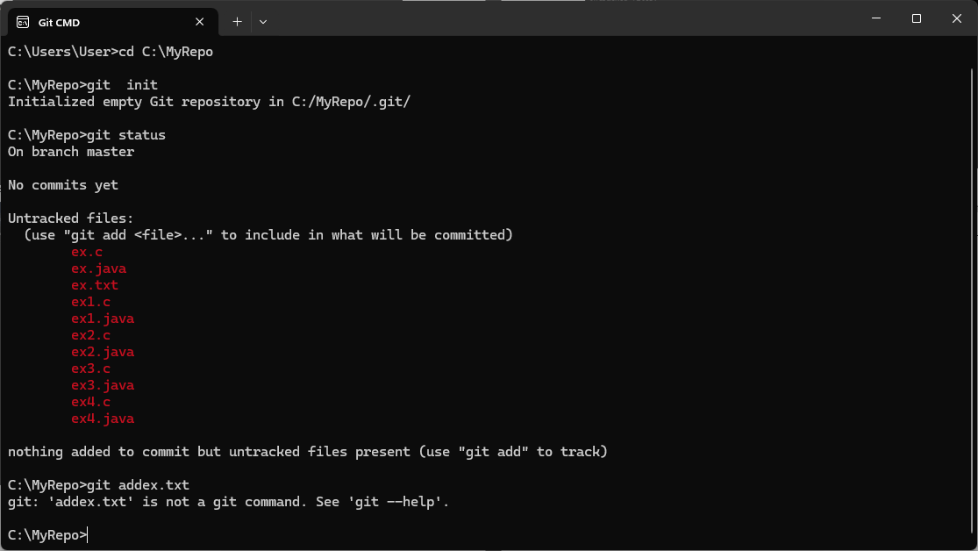

**5. verify the git status**

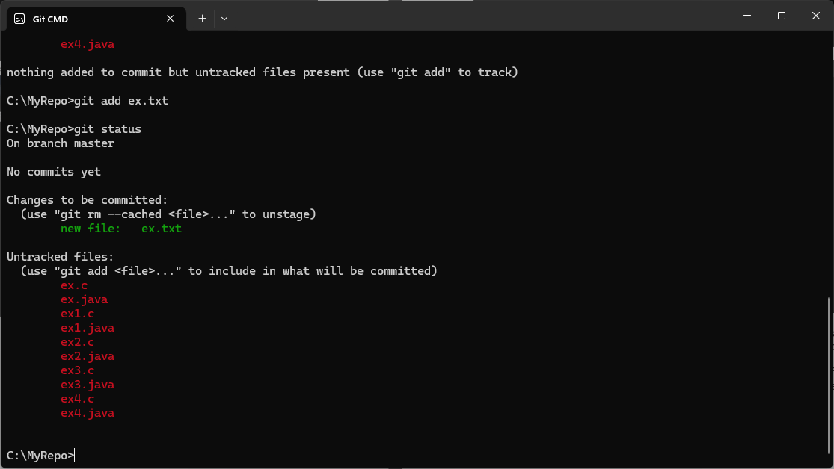

**6. Make a commit with the name "TXT Commit"**

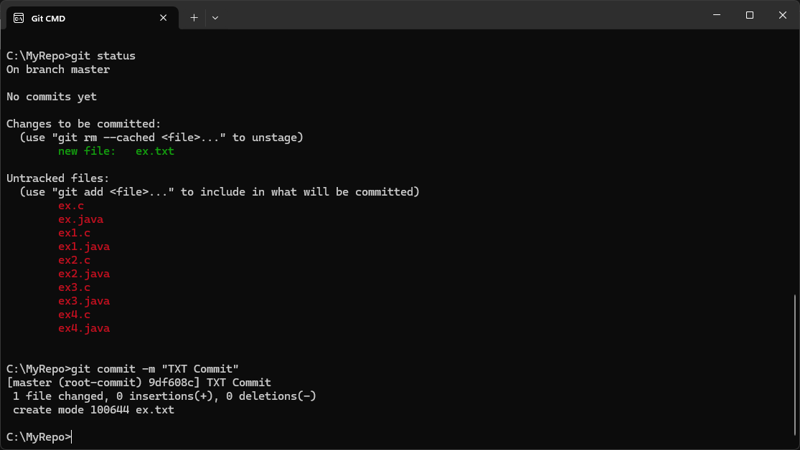

**7. Add all .c files into the staging area**

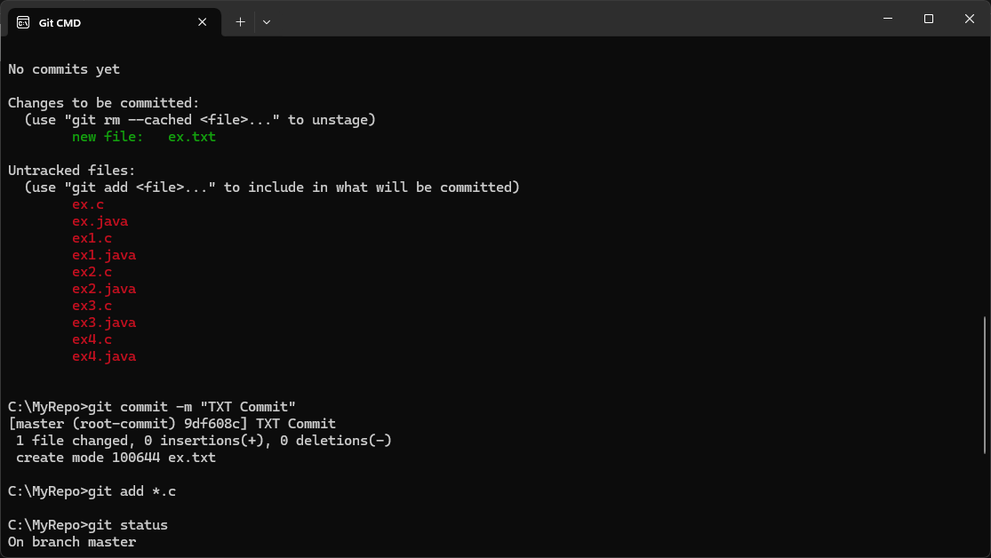

**8. verify the git status**

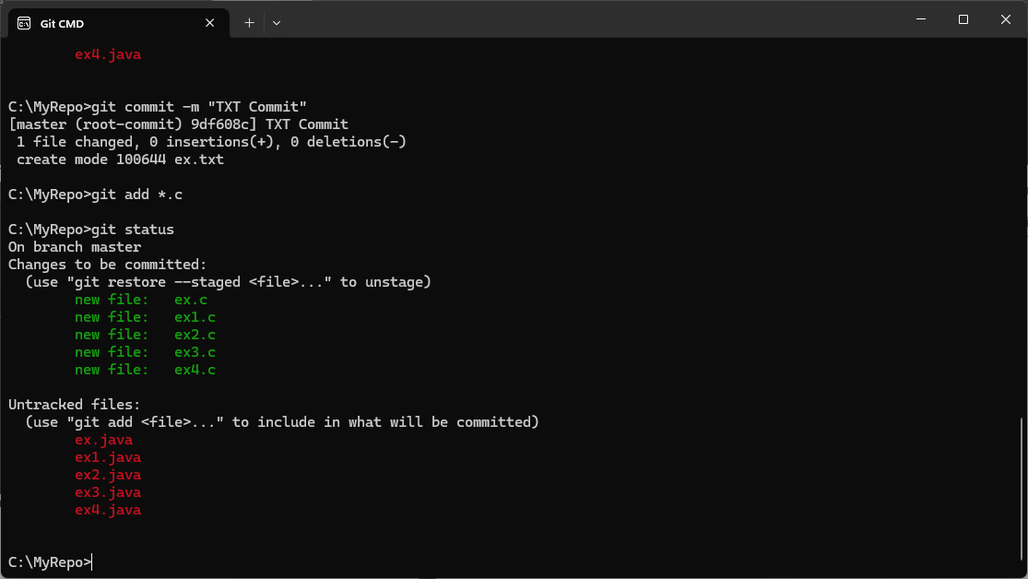

**9. Make a commit with the name "C Commit"**

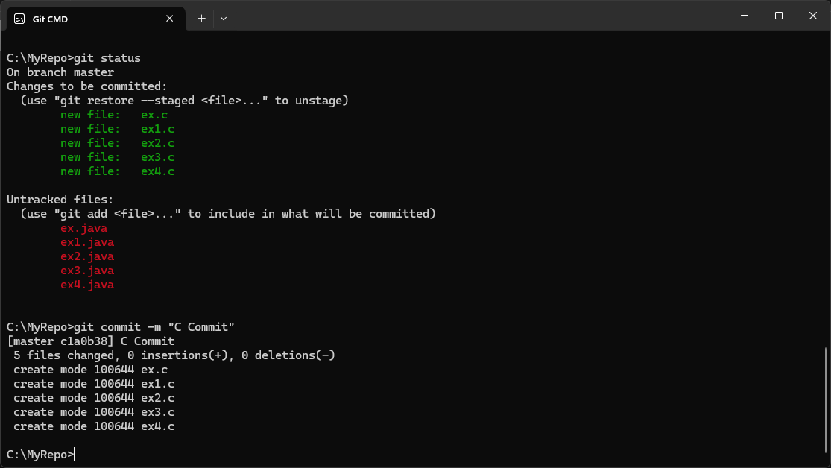

**10 .Add all .java files into the staging area**

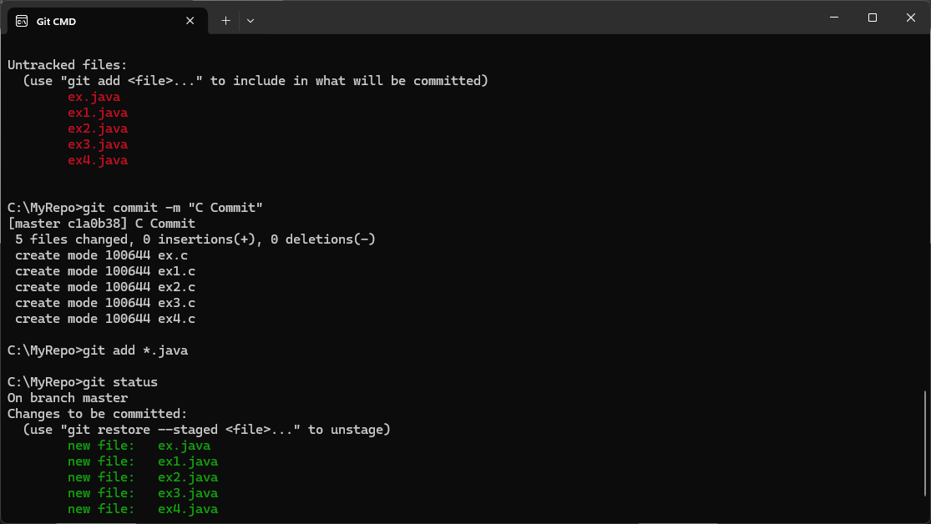

**11. verify the git status**

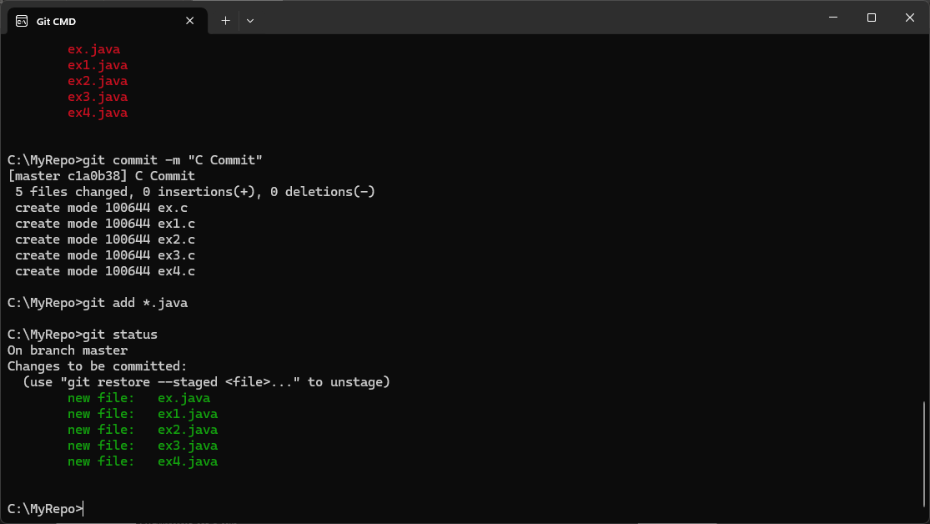

**12. Make a commit with the name "Java Commit"**

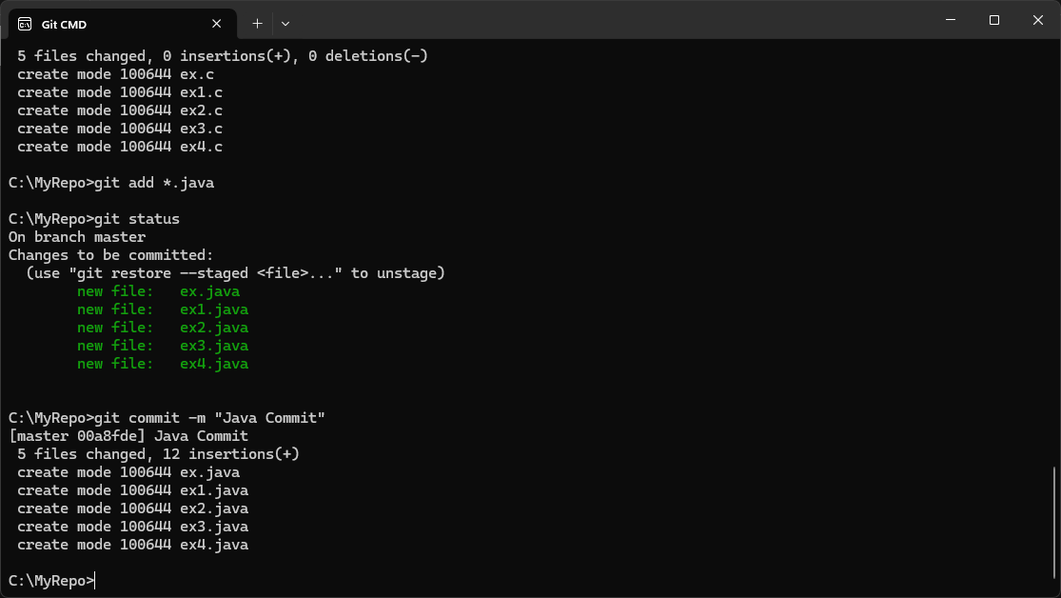

**13. Delete all .java files from working area**

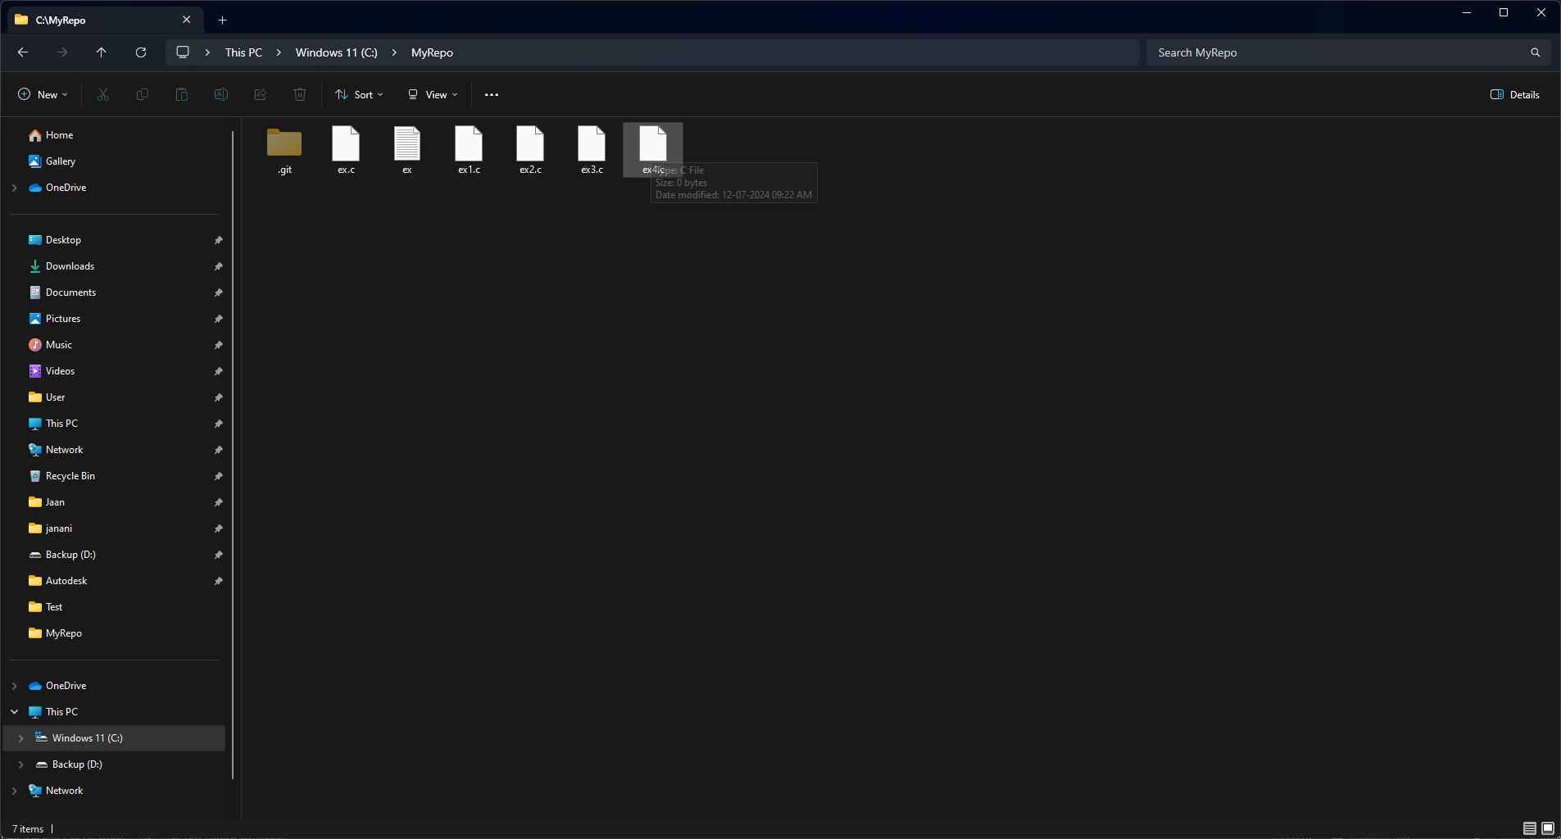

**14. Now see the status**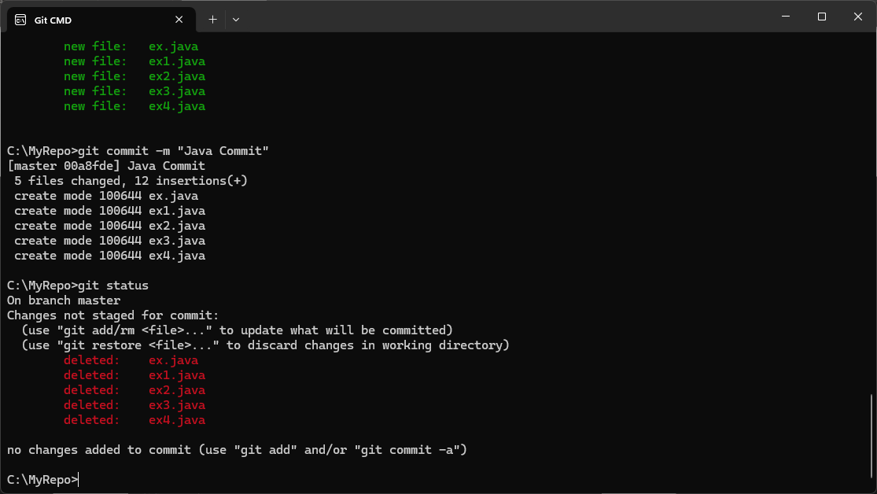

**15. add the changes into the staging area**

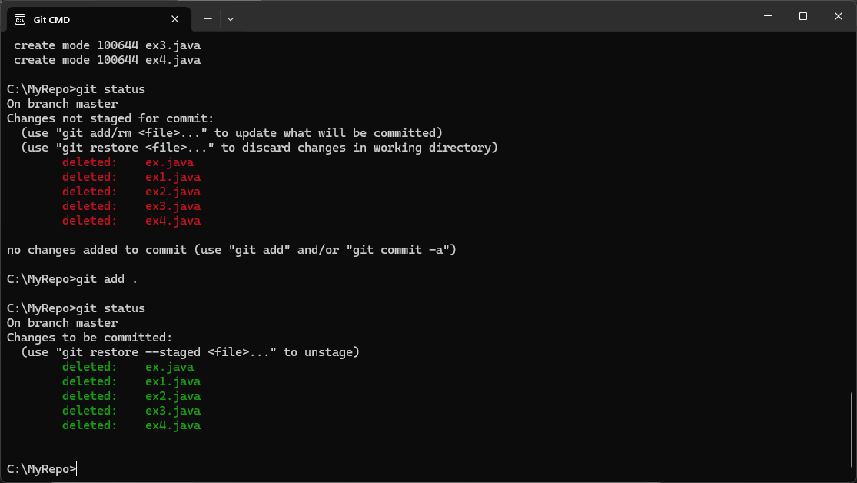

**16. Make a commit with the name "Delete Java Commit"**

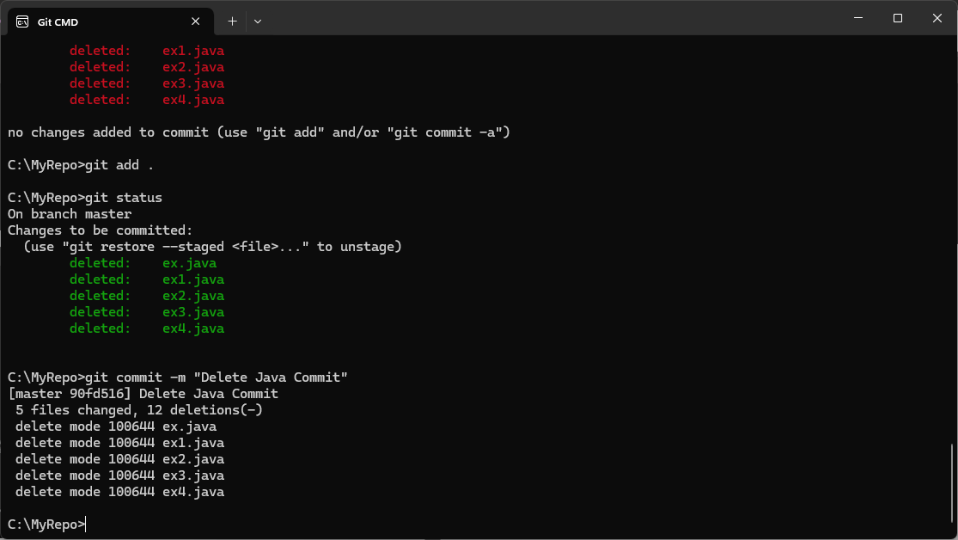

**17. display all commit details**

